1. Create 3 SQL queries (Test with good and bad data. Show any success messages and errors)

1. To insert data into a new row into an existing table.

Testing with bad data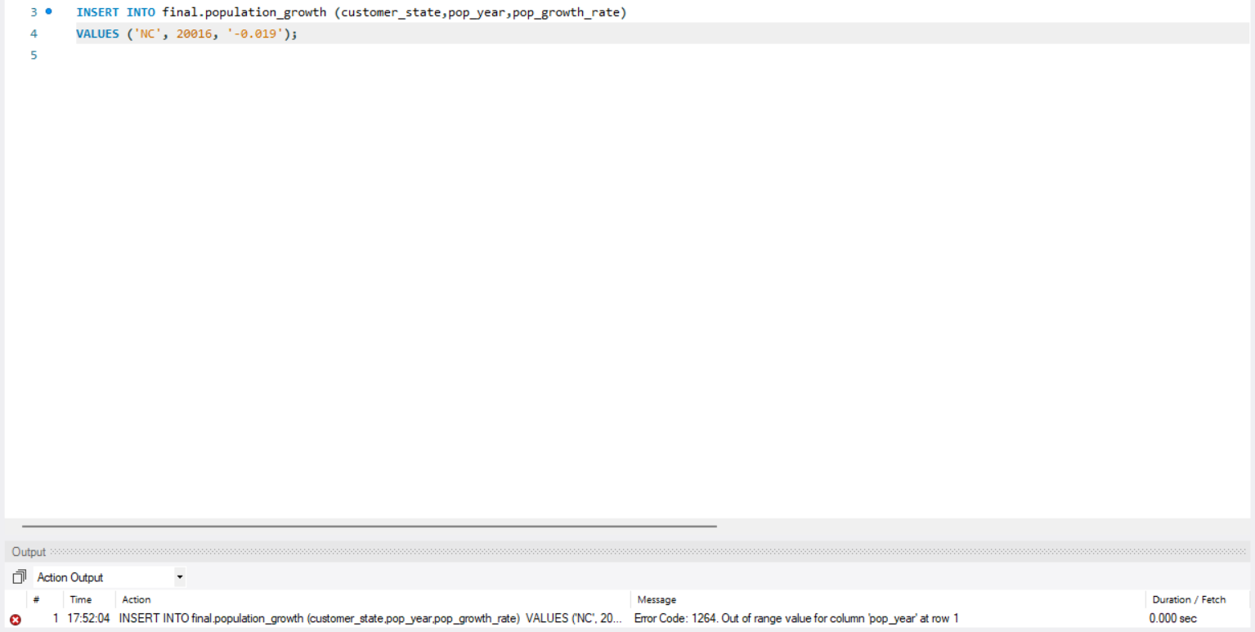17:52:04 INSERT INTO final.population_growth (customer_state,pop_year,pop_growth_rate) VALUES ('NC', 20016, '-0.019') Error Code: 1264. Out of range value for column 'pop_year' at row 1 0.000 sec

Testing with Good data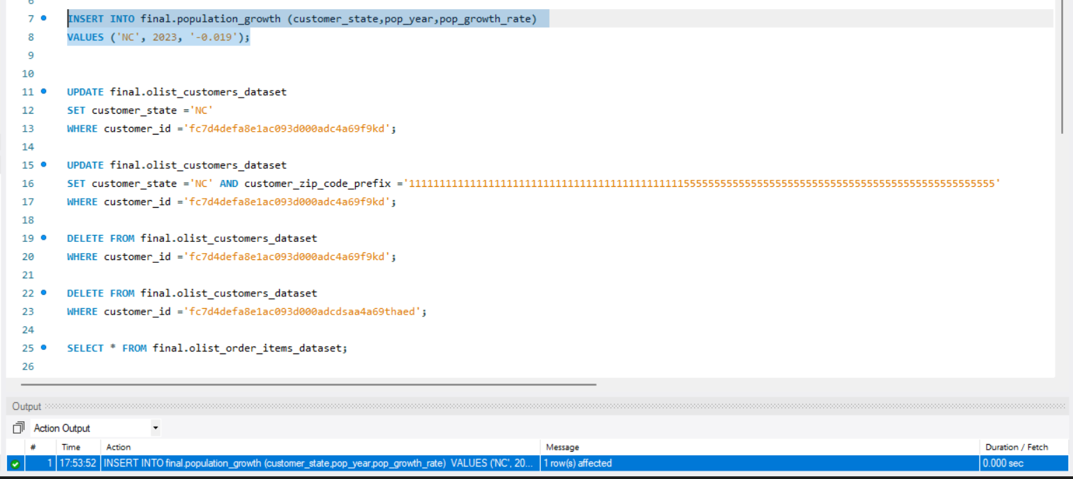

17:53:52 INSERT INTO final.population_growth (customer_state,pop_year,pop_growth_rate) VALUES ('NC', 2023, '-0.019') 1 row(s) affected 0.000 sec

1. To Update data in a existing row in a table.

Test with Good Data

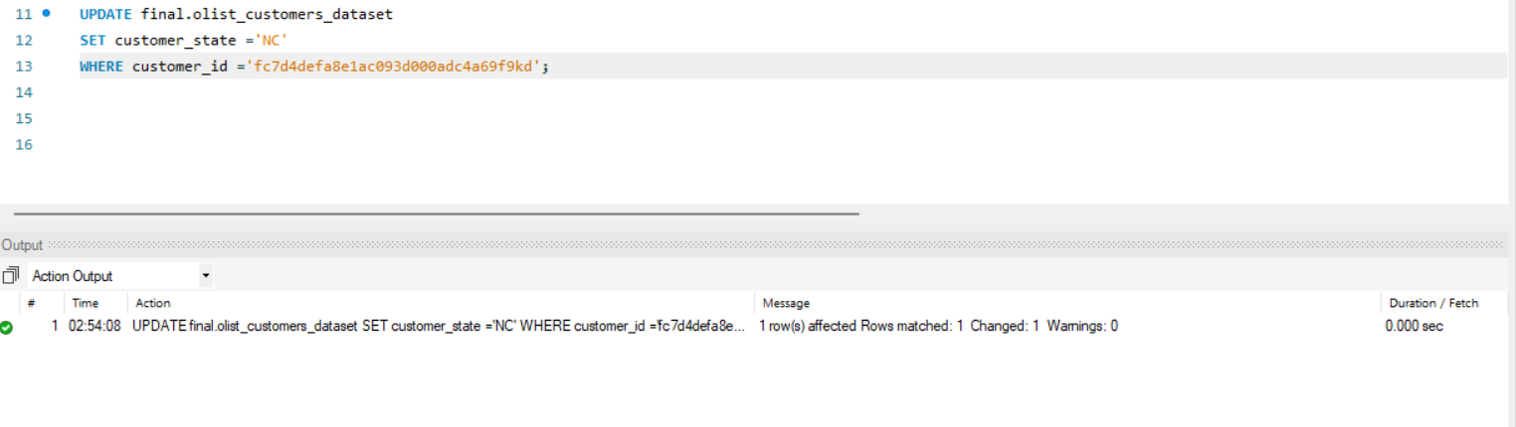 02:54:08 UPDATE final.olist_customers_dataset SET customer_state ='NC' WHERE customer_id ='fc7d4defa8e1ac093d000adc4a69f9kd' 1 row(s) affected Rows matched: 1 Changed: 1 Warnings: 0 0.000 sec

Test with Bad Data

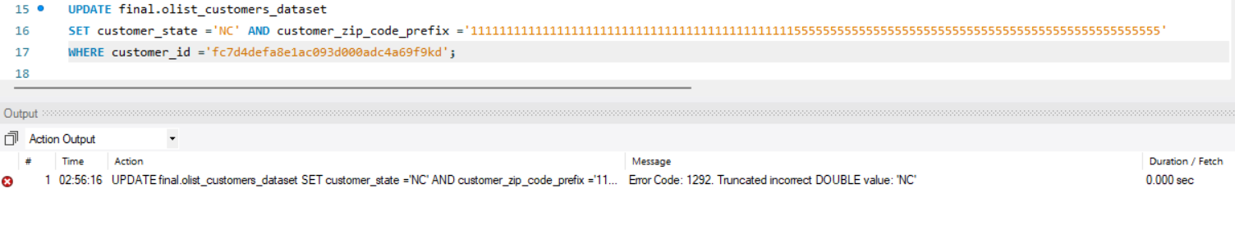

02:56:16 UPDATE final.olist_customers_dataset SET customer_state ='NC' AND customer_zip_code_prefix ='111111111111111111111111111111111111111111111555555555555555555555555555555555555555555555555555' WHERE customer_id ='fc7d4defa8e1ac093d000adc4a69f9kd' Error Code: 1292. Truncated incorrect DOUBLE value: 'NC' 0.000 sec

1. To Delete data a row in a existing table.

Test with good data

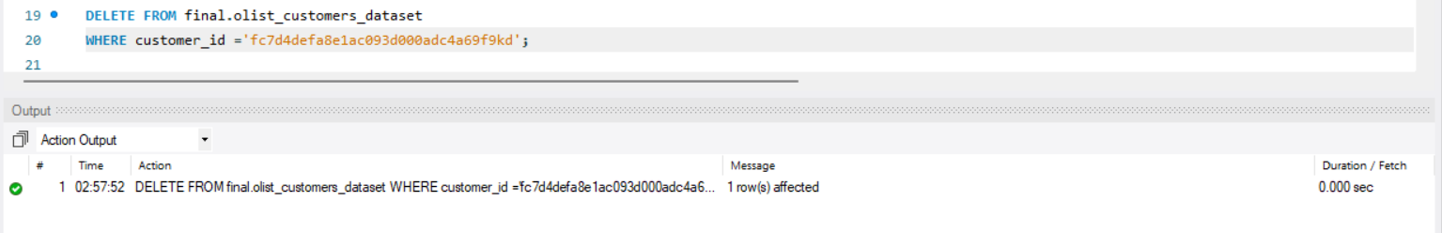

02:57:52 DELETE FROM final.olist_customers_dataset WHERE customer_id ='fc7d4defa8e1ac093d000adc4a69f9kd' 1 row(s) affected 0.000 sec

Test with bad data

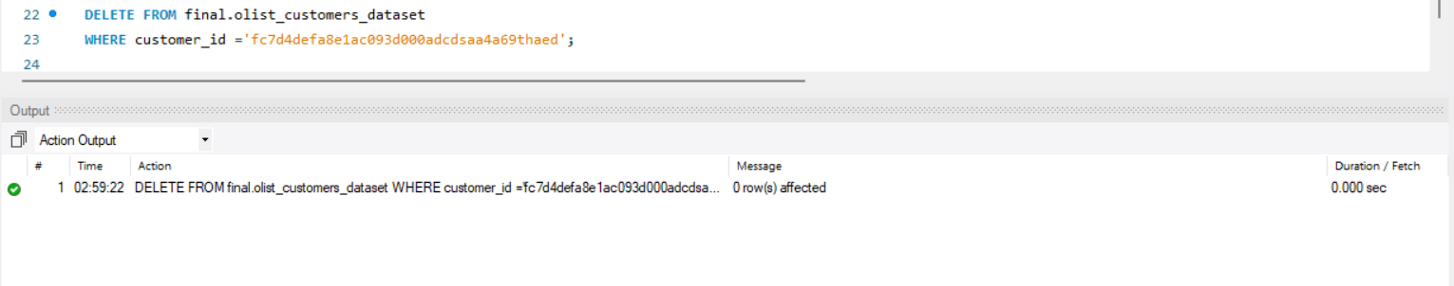 02:59:22 DELETE FROM final.olist_customers_dataset WHERE customer_id ='fc7d4defa8e1ac093d000adcdsaa4a69thaed' 0 row(s) affected 0.000 sec

2. Store Procedure – Pop_growth()

3. Custom Function get_states:

